

Editable text is underneath an image that has the wavy lines.

The wavy lines are superimposed on the text and then cleaned up in paint.net

**Unsung Heroes**

**Kellen West**

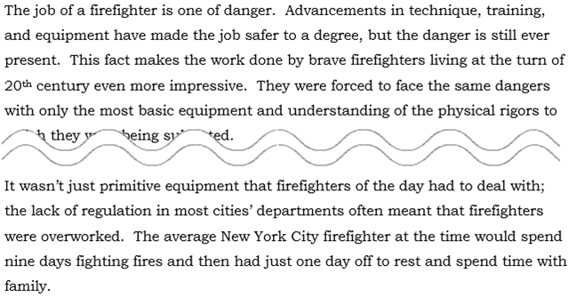

The job of a firefighter is one of danger. Advancements in technique, training, and equipment have made the job safer to a degree, but the danger is still ever present. This fact makes the work done by brave firefighters living at the turn of 20th century even more impressive. They were forced to face the same dangers with only the most basic equipment and understanding of the physical rigors to which they were being subjected.





It wasn’t just primitive equipment that firefighters of the day had to deal with; the lack of regulation in most cities’ departments often meant that firefighters were overworked. The average New York City firefighter at the time would spend nine days fighting fires and then had just one day off to rest and spend time with family.

Page numbers

Volume and issue

Journal name

***Journal of FirefightingVolume 12, Issue 1Page 130 (of 130-142)***